[](http://polyanovo.ru/content/stories/images/energo/365498.jpg)[](http://polyanovo.ru/content/stories/images/energo/big-38657-1.jpg)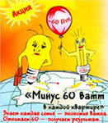 [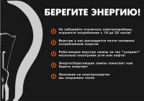](http://polyanovo.ru/content/stories/images/energo/666368.jpg)[](http://polyanovo.ru/content/stories/images/energo/003201.jpg) [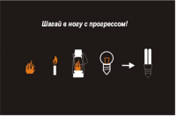](http://polyanovo.ru/content/stories/images/energo/untitled.png)   [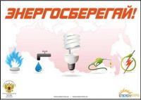](http://polyanovo.ru/content/stories/images/energo/1303998710_.jpg)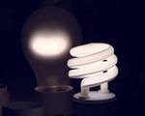 [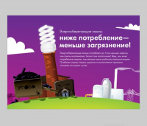](http://polyanovo.ru/content/stories/images/energo/untitled2.png)